F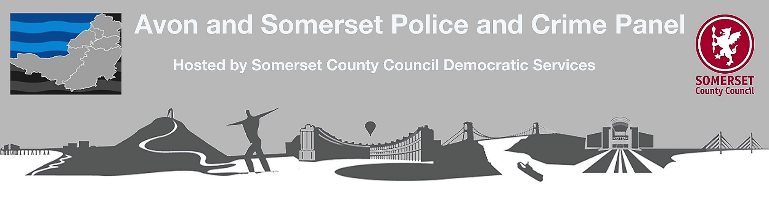
Link Member Report - Collaboration
Priority 4 – Working together effectively with other Police Forces and Key Partners to provide better services
I attended a meeting on 5th October 2018 with John Smith CEO and Mark Simmonds CFO. Below is a summary of the position as at this date in relation to Priority 4 collaboration.

Tri Force Firearms, Roads and Dogs and Major Crime – Avon and Somerset continues to work towards hosting a joint firearms/training service with Gloucestershire and Wiltshire. A headline structure has been agreed but further discussions around final options need to take place.

Arrangements between Wiltshire and A&S will continue on roads. Dogs are also an option subject to value for money. Gloucestershire will make its own arrangements on roads and dogs. It is intended to implement this by April 2019 and the situation remains challenging but no additional cost implications are anticipated. I did raise the concerns as to what would happen on roads that cross the border such as the A38. At the moment, A&S is required to respond to events on the Gloucestershire side of the border as if it were in A&S. After the current arrangement ends they would respond if called upon and if there was available capacity – other Forces would also be called upon by Gloucestershire.

South West Regional Collaboration and National Specialist Capabilities Programme
The merger between Devon and Cornwall and Dorset has collapsed. Devon and Cornwall Police and Crime Panel have voted to back the decision of their PCC Alison Hernandez, to reject the merger plans. The PCC takes the view that Devon and Cornwall Police would not benefit from a merger because council tax would have to fall in Dorset to bring it in line with the level charged in Devon, rather than D&C’s rising to the level of Dorset. This essentially removes any financial incentive to merge.

The full implications for the rest of the programme are still to be worked through. There are a number of ongoing 5 force (Regional Organised Crime Unit) and 4 force (Special Branch and Forensics excluding Glos)) collaborations which are working successfully. The Forensics programme is also moving to a host force model to address system and HR issues - Dorset will host these pooled services. This will involve a transfer of staff to Dorset. Wiltshire’s IT arrangements as they stand are hosted by another partner and not accessible by other partners. A&S largely already operates central systems for Regional Organised Crime.

There is a national Specialist Capabilities Programme looking at a national networked approach across a number of specialist functions. A&S support this and it includes the National Police Air service. A drone is currently being trialled with Wiltshire – the helicopter lends itself well to dynamic situations and drones for surveillance/scanning work.

In a bid to make headway on a collaborated Enterprise Resource Planning/Payroll/HR solution, A&S has looked at a Cheshire Police led consortium. Whilst initially significant savings were anticipated, their platform and cost profile is currently too unstable – A&S need a medium term solution. A&S will continue with the current SAP solution for the medium term – licences are paid for and the procurement process has started. National collaboration opportunities can be looked at in a few years.

Other Emergency Service Collaborations
A&S continues to participate fully in the South West Emergency Services Collaboration involving police, fire and ambulance across the South West. The PCC is not able to progress a fire governance business case without a change in fire and/or Police boundaries. This is not currently being considered. Collaboration work with both local fire authorities is being taken forward especially in relation to estate such as Joint HQ, Nailsea and Southmead. But there are limitations as to what can be progressed with Avon Fire.

By 2020, the Airwave Project will be nearing the end of its life and radios will need to be replaced with an alternative device. A move to a high band Police 5G network is currently running as a national project – regionally coordinated. Mobile smart phones are being rolled out and will be replaced in 2021/22 to line up with the end of the Airwave Project.

Criminal Justice
There is considerable work underway with CJ partners and the voluntary sector and reducing reoffending is a key priority. As previously reported to the PCP, a CJ Transformation post has been funded with partners to look at CJ efficiency and effectiveness, victim focus and implementing the Lammy review. A Reducing Reoffending Executive Board has been set up and a memorandum of understanding agreed with the Ministry of Justice to co-commission local reducing reoffending services.

The Deputy Governor of Bristol Prison has started a one year secondment to the OPCC match funded by the MoJ. Work is focussing on prisons in Bristol and Dorset.

Local Authority and health
Collaboration with local authorities on a range of commissioning activity is established - co-commissioned services with health colleagues including control room triage service, Sexual Assault Referral Centres, ISVAs and Custody and Courts Referral Service. Financial pressures on these partners is a concern.

10% of the Budget is dedicated to collaboration and this has released savings. A&S has been required to restart enabling services internally and has made its own savings in the region of 10%. There are still savings to be made but the right partners are needed.

Conclusion
It is concerning that some of the tri-force collaboration is ending. I would hope that the D&C and Dorset merger failure would reopen additional possibilities for greater 4 or 5 force opportunities. I have no concerns at present.

Councillor Mark Weston

Addendum – 20th November 2018

Gloucester decided several months ago that they wished to take back several aspects of the existing Tri Force (with Avon and Somerset and Wiltshire) Specialist Operations Project to local control. In addition, Avon and Somerset wished to act on the recommendations of several independent reports on the Specialist Operations Project and change the model so that systems and staffing issues were dealt with under a single host force model and not as currently via 3 separate force systems and terms and conditions.

Despite lengthy and detailed discussions, it has not been possible to reconcile Avon and Somerset’s desire to address the recommendations in the reports by adopting the hosting model with Wiltshire and Gloucestershire’s requirements to retain control over assets and staff locally. It is therefore intended that Avon and Somerset will withdraw from the Tri Force Specialist Operations collaboration next April. The detailed arrangements are still being worked through but there are not expected to be significant operational consequences for Avon and Somerset.

