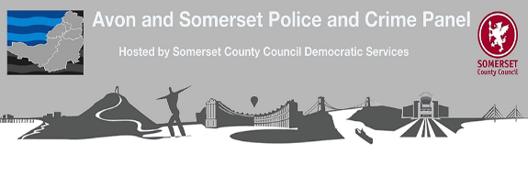
Openness and Transparency - payments over £500
The Local Government's Transparency Code contains a number of requirements, one of which is to publicise expenditure over £500. The Police and Crime Panel is required to submit annual returns to the Home Office detailing the expenditure in order to receive the grant that is payable to administer the Panel. Below shows the allowance paid to Panel members from the grant funding in 2025/26 (tax excluding):-
Panel Member | Amount Paid 2025/26
Sibusiso Tshabalala | £920
Federica Smith-Roberts | £920
Richard Brown | £920
Brian Bolt | £920
Martin Wale | £920
Lisa Durston | £920
Heather Shearer | £920
Simon McCombe | £357.79 (pro-rata)
Cara Lavan | £920
Andy Wait | £920
Nicola Clark | £920
Ash Cartman | £920
Raj Sood | £920
Julie Knight | £920
Gary Davies | £920
Peter Crew | £920
John Bradbury | £920

